Chapter 16, Problem 17.

If i_{s}(t) = e^{-2t}u(t) A in the circuit shown in Fig. 16.40, find the value of i_{o}(t).

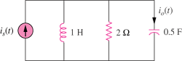

Figure 16.40
For Prob. 16.17.

